Andrew Ha   
November 2015

Part C)

1. Purpose – The purpose of the website of this website is to inform clients and potential clients about your business, the services you offer and the cost of those services.
2. Audience – The audience of this website are going to be families, dog owners, older adults, seniors and young couples. Generally the targeted group are going on vacation, and are the middle classed and above. They are more often than not white collar workers with spare capital. Our target audience is in the Ottawa/Gatineau region.
3. The different pages will be first a home page, a page that gives information about the service (area, types of services), a page for the prices and a page about the hours. Also included will be a testimonials/reviews page. Also there will be a staff page, contact page, and a links page.
4. Structure –   
   a) How the page will be organized is that it will be in a hierarchical format. It will consist of 5-9 different subsections in total.

b) The types of navigation that we will be using is a breadcrumb navigation, it will be under the navigation bar and it will have breadcrumb trail allowing potential clients to retrace their steps. Also at the bottom of the page will be a footer that will have hyperlinks in that will link to things such as contact information, services, etc. (anything that is not in the navigation bar).

c) Logo - 

7.) Wireframe – Homepage

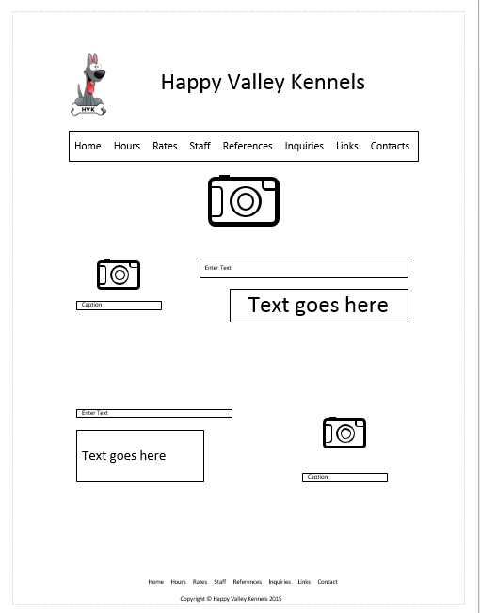

7.2) Wireframe – Subsequent Pages

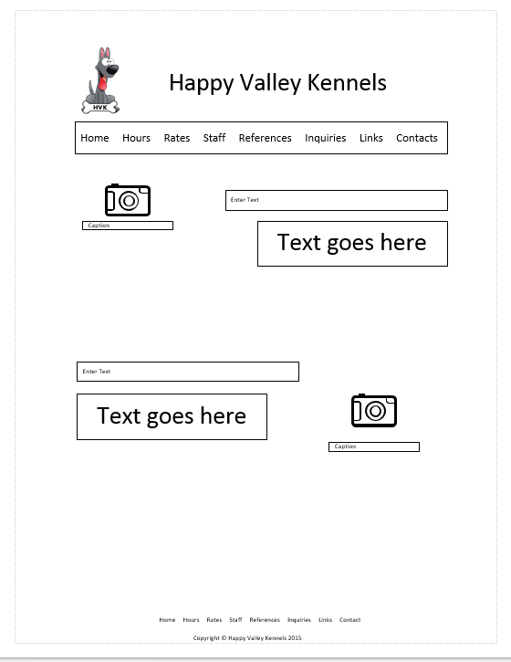

Wireframe 7.3 – Mobile

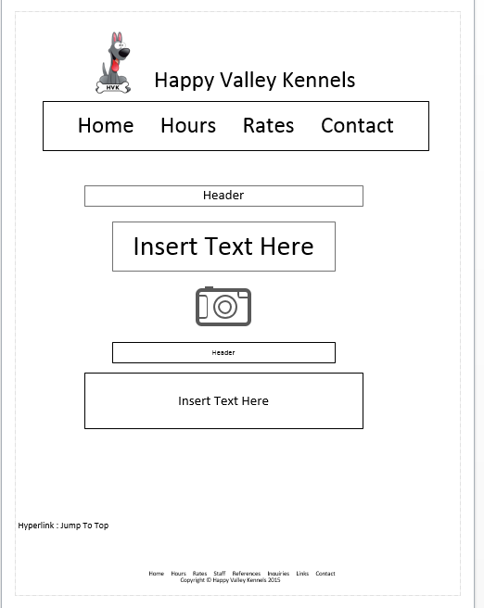

Colour palette :



#AEB05D



#FEFFD3

  
#7F7F6A



#D3A46E



#FFFFFF